Chair Application Form
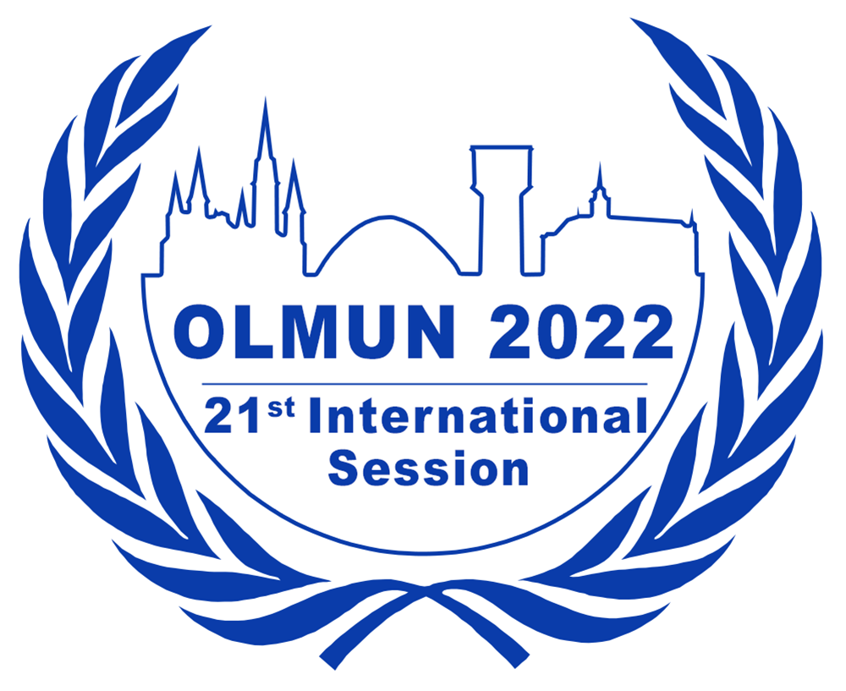

June 21st – June 24th, 2022
www.olmun.org

Per C. Pagnia
President of the General Assembly
Unter den Eichen 46
26122 Oldenburg - Germany
0049 (0)171 4174449
president@olmun.org

To apply for a chair position at OLMUN 2022, please complete this form and send it to president@olmun.org by the following deadlines:
- December 21st (11:59 pm) if you are a member of the OLMUN e.V. (internal application)
- December 28th (11:59 pm) if you are not a member of OLMUN e.V. (external applicant)
If you are an external applicant, please ask a referee (your MUN-Director or any other eligible referee) to send a Letter of Recommendation to president@olmun.org by December 28th.

The interviews should take place within two weeks from either deadline and will take around 30 minutes each.

Name: | School/University:
Gender: | Field of study:
Date of Birth: | Phone:
Nationality: | Mobile:
Graduation: | Home address:
Grade/Semester: | E-mail:

Last English mark/course:

Do you have any English Language Certificates or other considerable qualifications concerning your English language abilities (such as a stay abroad)?

Please state your MUN experience.

Date (Month/Year) | Conference | Position/Committee

Which of the committees available at OLMUN 2022 (see below) would you like to chair?

Please give reasons for your choice.

The following committees are available at OLMUN 2022:

Economic and Social Council (ECOSOC)
The first General Assemlby (GA1st)
United Nations Environmental Programme (UNEP)
Human Rights Council (HRC)
Special Conference (SpC)
United Nations Entity for Gender Equality and the Empowerment of Women (UN WOMEN)
Social, Cultural and Humanitarian Committee (SOCHUM)
Arctic Council (AC)
Security Council (SC)

(For detailed information on the committees visit olmun.org)

In order to assess your suitability for a chair position at OLMUN 2022, we would like you to answer a few questions. There is neither a minimum nor a maximum length for these answers.

1. What do you think qualifies you for an OLMUN chair position?

2. What is your personal motivation for applying for a chair position and what do you wish to accomplish for yourself through your participation in the OLMUN chair team?

3. How do you think a committee should be chaired and why?

In case of any concerns and questions, please do not hesitate to give us a call or contact us via e-mail (president@olmun.org).

